- LGYC Winter Newsletter

Ahoy Matey’s!
Well, we have come to the end of another year, and it has been jam packed with a lot of fun.

Thanks to the combined effort of our Entertainment Chairs, Boyce and Resa Ross and their talented committee, our Labor Day party was a HUGE success. What better theme for an outdoor affair than a circus! Our docks were filled with boats from Turtle Point and Chattanooga. Turtle Point actually had more boats than Chattanooga this year and they came to PARTEE’.
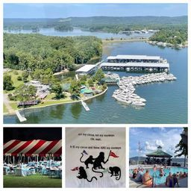

The light show around the gazebo was mesmerizing and everyone had a great time dancing the night away with Junctional Rhythm.
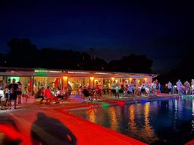

Of course, the game of Pin the Speedo on the Commodore was the most visited. Billy and Paula, great idea!
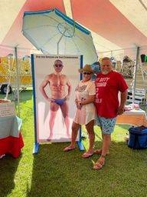

Ringmaster Gerald and I had a great time with the Toilet Tissue Toss:
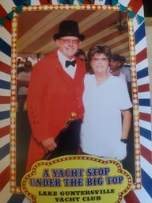

Next up, we celebrated the new 2021 Commodore & Commodorable, Gerald and Gail Daniel. It was a great night, and we really appreciate each of you, and will treasure the time we’ve had serving the club. We wish the incoming 2022 Commodore & Commodorable, Chuck and Amy Wills, and Bridge smooth sailing for the New Year!
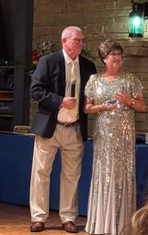

2021 Bridge & wives and 2020 Past Commodore & wife:
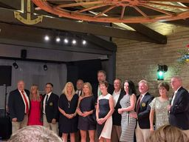

Thank you to the Bridge Wives for making the clubhouse shine with the decorations and flowers.
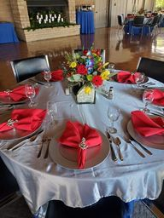
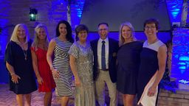
(Not pictured: Pam Bosse who was celebrating her mother’s birthday in the beautiful state of Maine)
November 7th, we celebrated Heroes Week at the club and had 9 boats who carried the veterans out on the water with a parade ending at City Harbor, so the crowd could salute them. Once back at the club, the children’s choir sang, and we had a great meal provided by Wintzell’s. It was a great day had by members, visitors, and veterans!
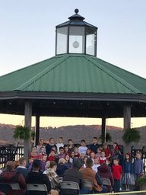

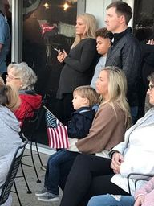
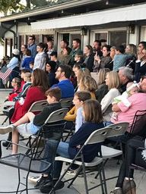

Last, but certainly not least, we had our Christmas Brunch and enjoyed the sights of all the clothes, bikes and toys that were given to the Christmas Coalition this year from the club. Thanks to Sara Grace and her great shopping skills, we were able to provide 20 families with some Christmas joy. The generosity of our members was greatly appreciated, and we were able to give additional funds to the Coalition to provide for other needy families.

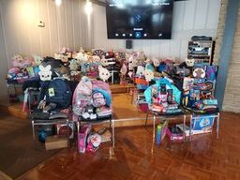
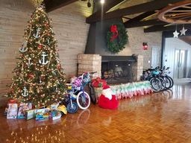
Another surprise guest was Santa dropping in to say hello and thank you for making his job a little easier!
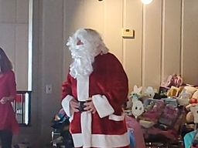

Well, the only thing that is left in the year is the New Years Eve party which will be included in the New 2022 year’s Newsletter.
After 3 great years (unfortunately 2020 was a year to forget) of providing the news to the club, I am passing my “pen and paper” to Sara Grace. I have enjoyed sharing newsworthy items with you and I know Sara Grace will have plenty to share as well.
If you have important news that you wish to share with the Club, be sure and send it to Sara Grace. She will also be the point of contact to notify the club of a member passing or someone in their immediate family.
Carol Turner is still handling any cards or flowers to be sent to a grieving family or a member who might have been in the hospital for major surgery.
Chuck Wills is still the administrator of the Wild Apricot website and can assist you with any changes you need.
Pete Van Staagen will be the 2022 House & Grounds person and can answer any questions concerning the clubhouse and grounds.

Thank you for all your responses over the years to the Newsletters. I’ve really enjoyed being the POC for the club news!
Remember to “Be Calm and Sail on!” 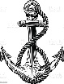
Gail

